# Title: Marketplace Overview

## **Why Marketplace?**

     To solve use case scenarios that apply to a subset of a customers apps can be built and published in marketplace for use by customers.

## **Classification of Marketplace apps**

Based on where the code resides

* Native integration
* Marketplace apps
* Custom apps
* External apps

Based on the type of the app,

* Frontend marketplace app
* Serverless app

## **Marketplace Architecture**

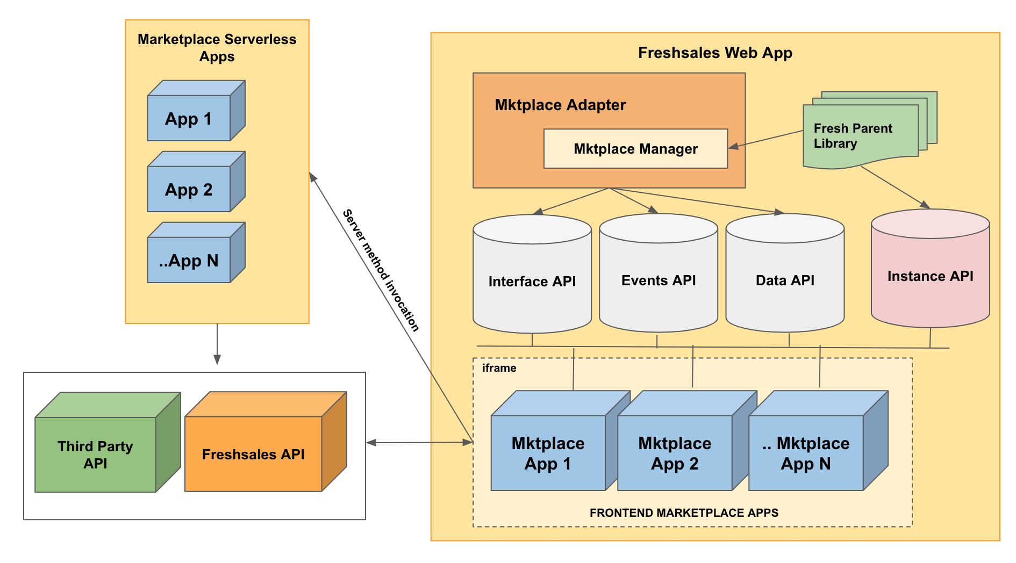

## **Writing your first app**

1. Use **fdk create** to select a product and then select a template
   1. Select Product
   2. Select Template
2. Project folder structure

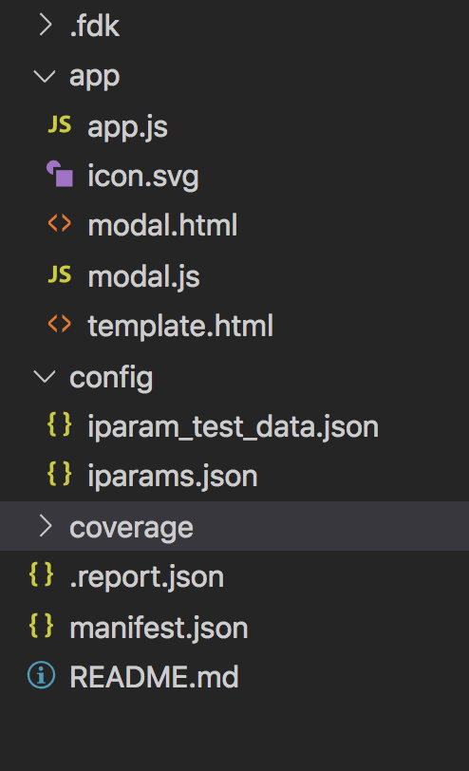

3. Use **fdk run** to run the project locally and serve it

4. Hit any of the landing pages and use query param **?dev=true**to visualise the created app

[http://local-freshsales-app-domain.freshsales-dev.com:3000/leads/3?dev=true](http://umashankar-masilamani.freshsales-dev.com:3000/leads/3?dev=true)

## **Marketplace App Supported Locations:**

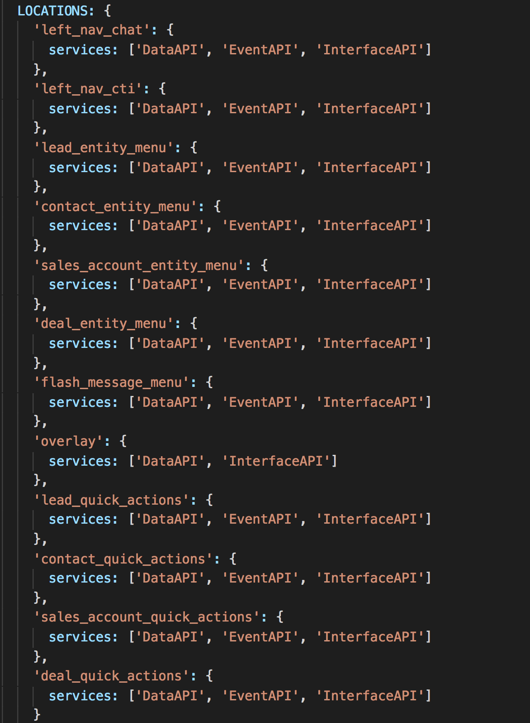

## **App Lifecycle events:**

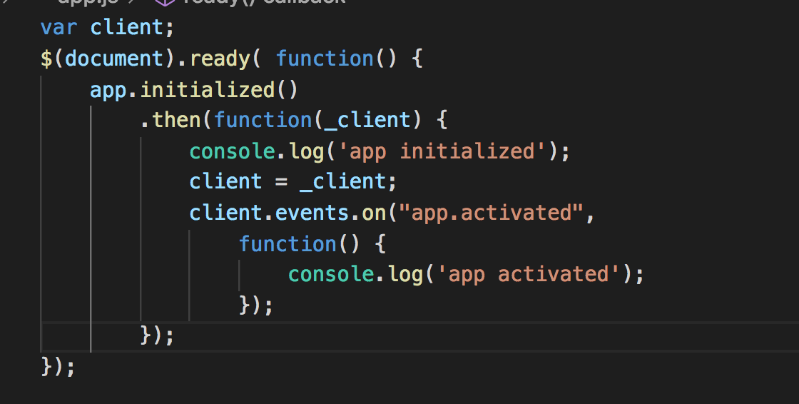

## **Installation Parameters:**

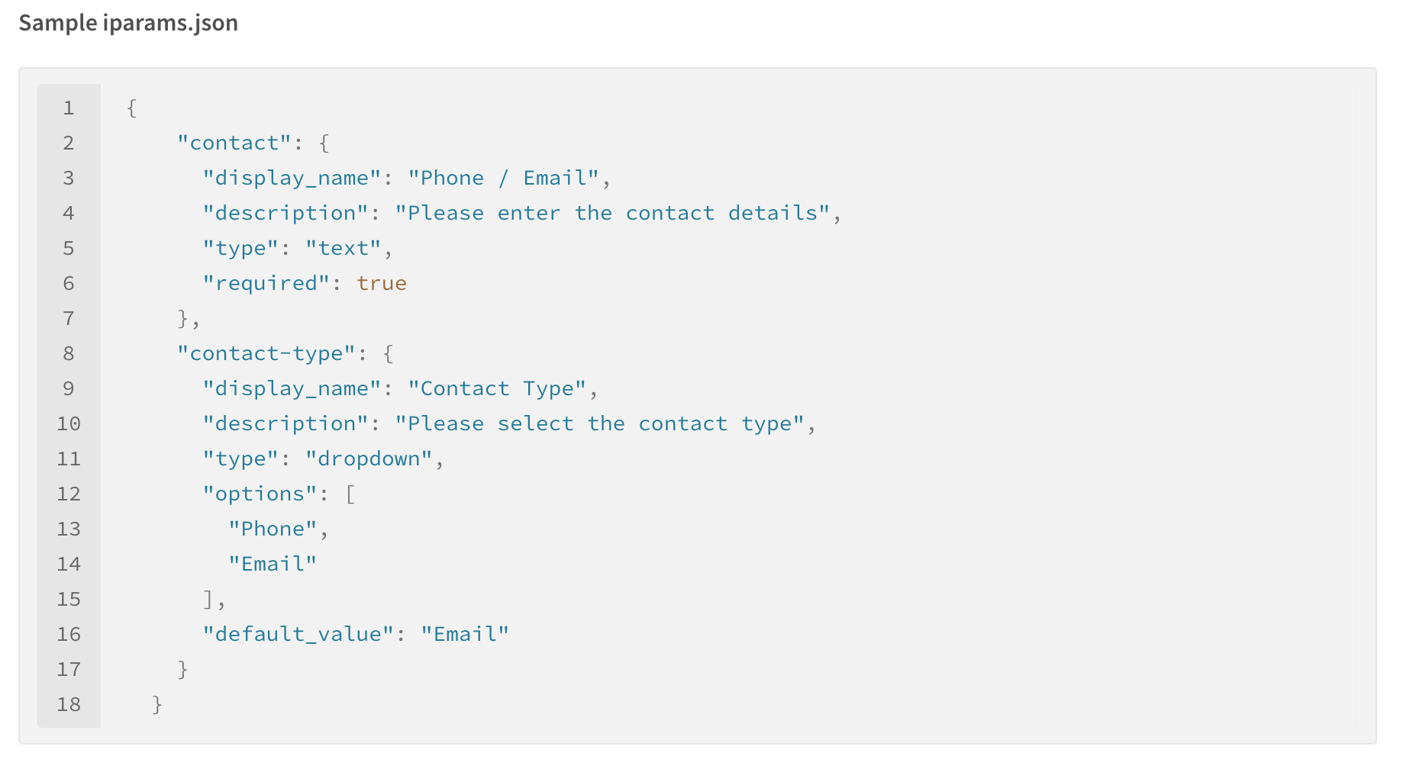

some additional attributes:

* secure
* data-bind
* regex

list of all supported field types: <https://developers.freshsales.io/docs/installation-parameters/#types>

Or use  **iparams.html** to completely customise the user interface of the installation page

**client.iparams.get()**

**client.iparams.get(iparam_key)**

## **Data API**

Used to get data from the parent freshsales web app. Only data exposed by the freshsales app can be retrieved

**How to get data?**

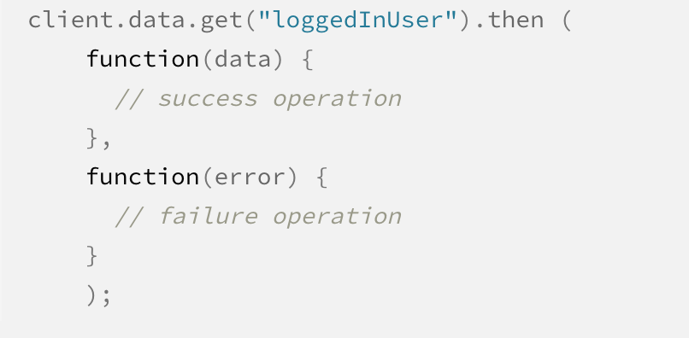

**What all data can we get?**

**1. loggedInUser**

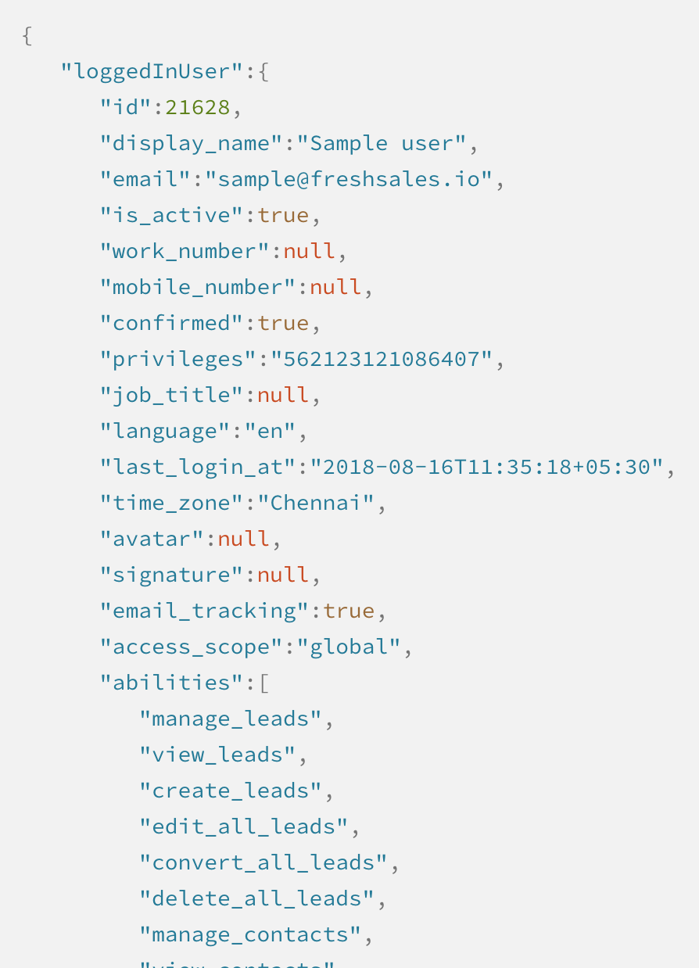

**2. currentEntityInfo**

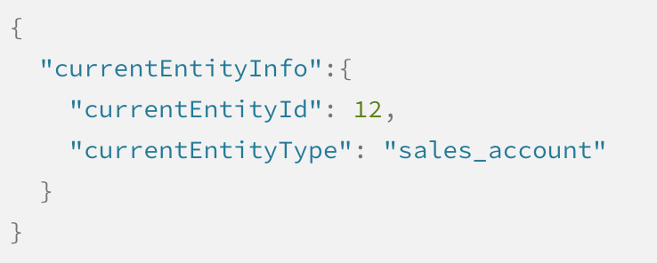

## **Events API**

Lets app react to specific events published by the freshsales web app

**How to get data when a particular event occurs?**

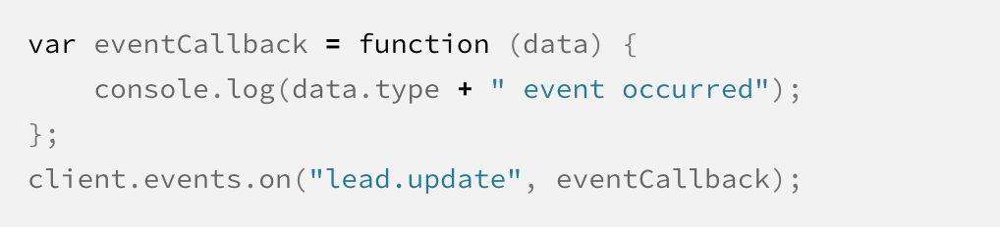

data.helper.getData() => gives data provided by the event publisher

**What all events can we listen to in freshsales?**

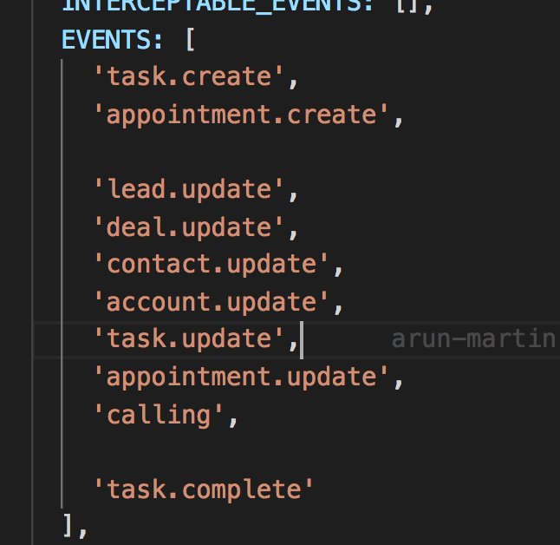

## **Interface API**

Can be used to leverage on existing user interface elements on the parent freshsales app for use in our marketplace apps

**How to trigger interface API?**

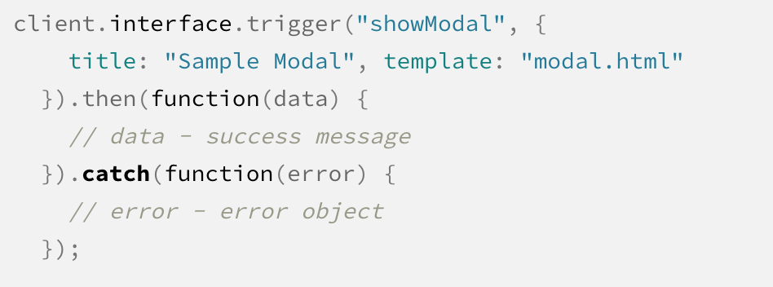

**What all interface elements can be used?**

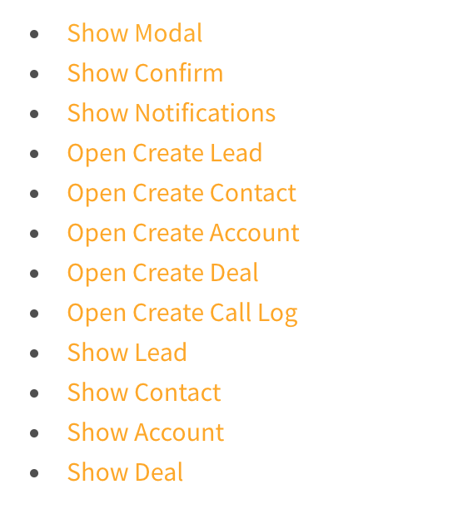

**Eg: Show Modal**

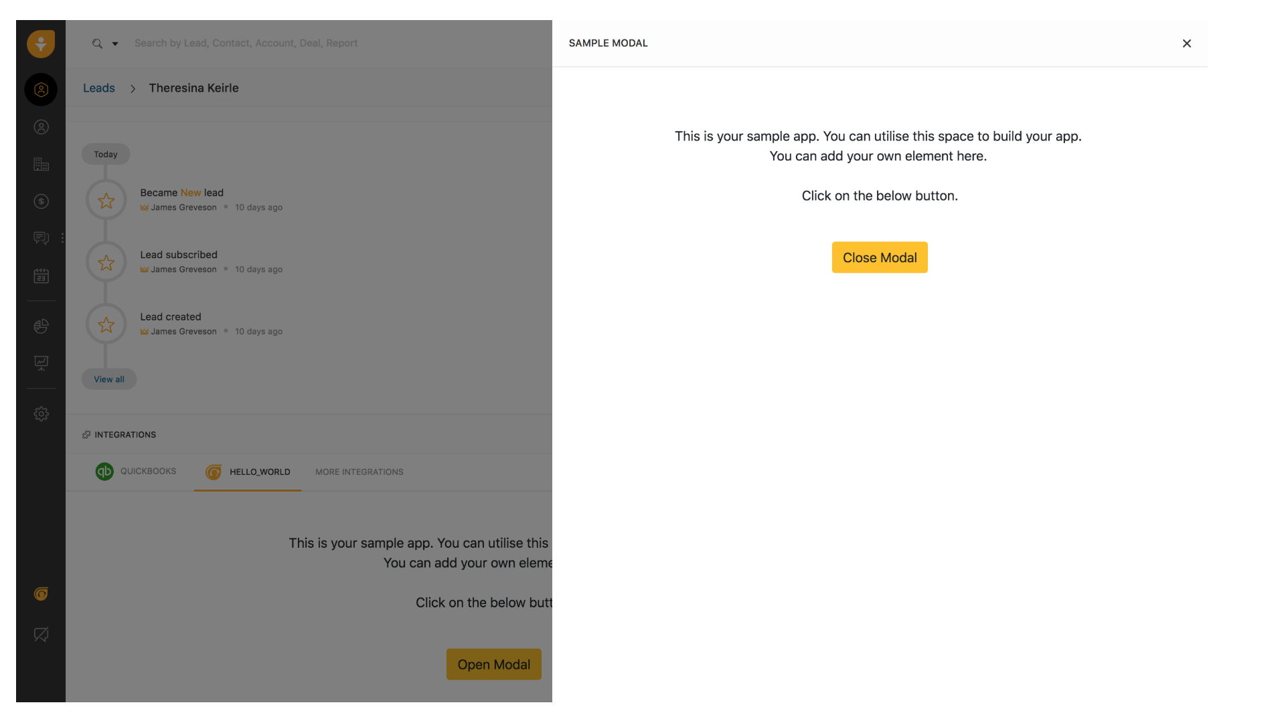

## **Inter App Communication**

As one single app can be loaded onto multiple locations, marketplace library would create multiple instances of that app and to facilitate communication between them, we can use instance API

**Instance API**

To understand about the current instance

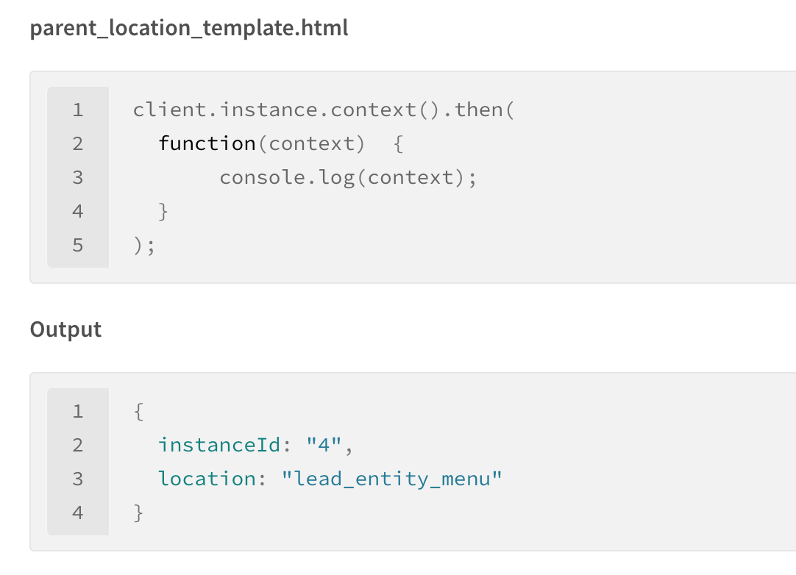

To get info all active instances

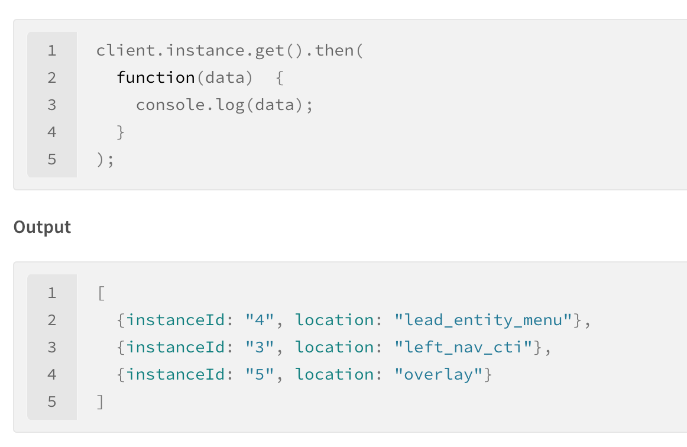

To send data to another instance

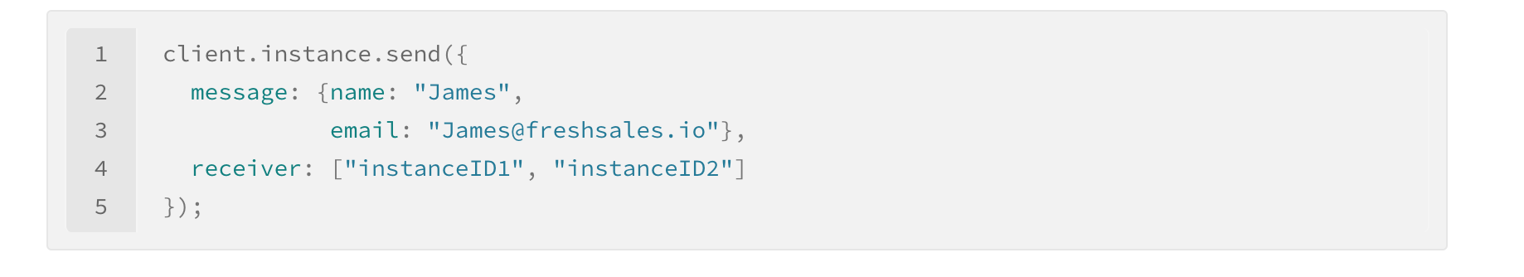

To listen for data from another instance

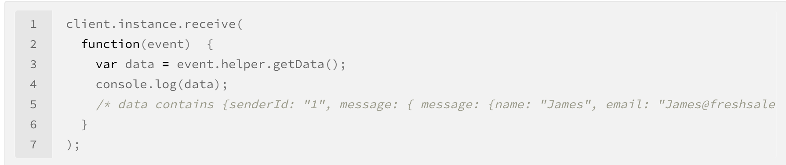

Sending data from parent to child

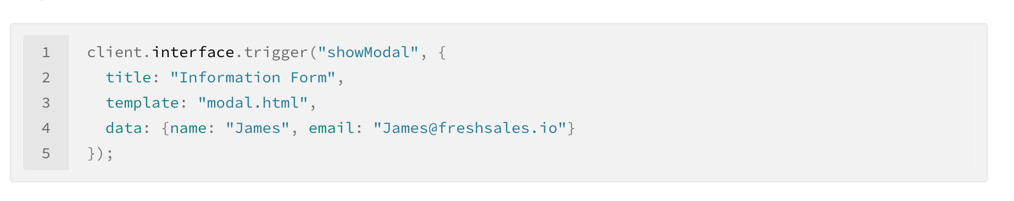

How child can consume above data?

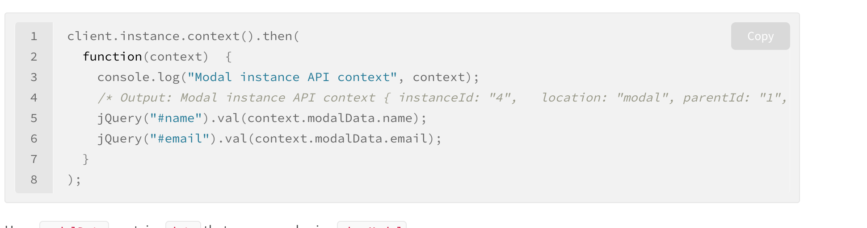

## **Serverless apps**

How do they work?

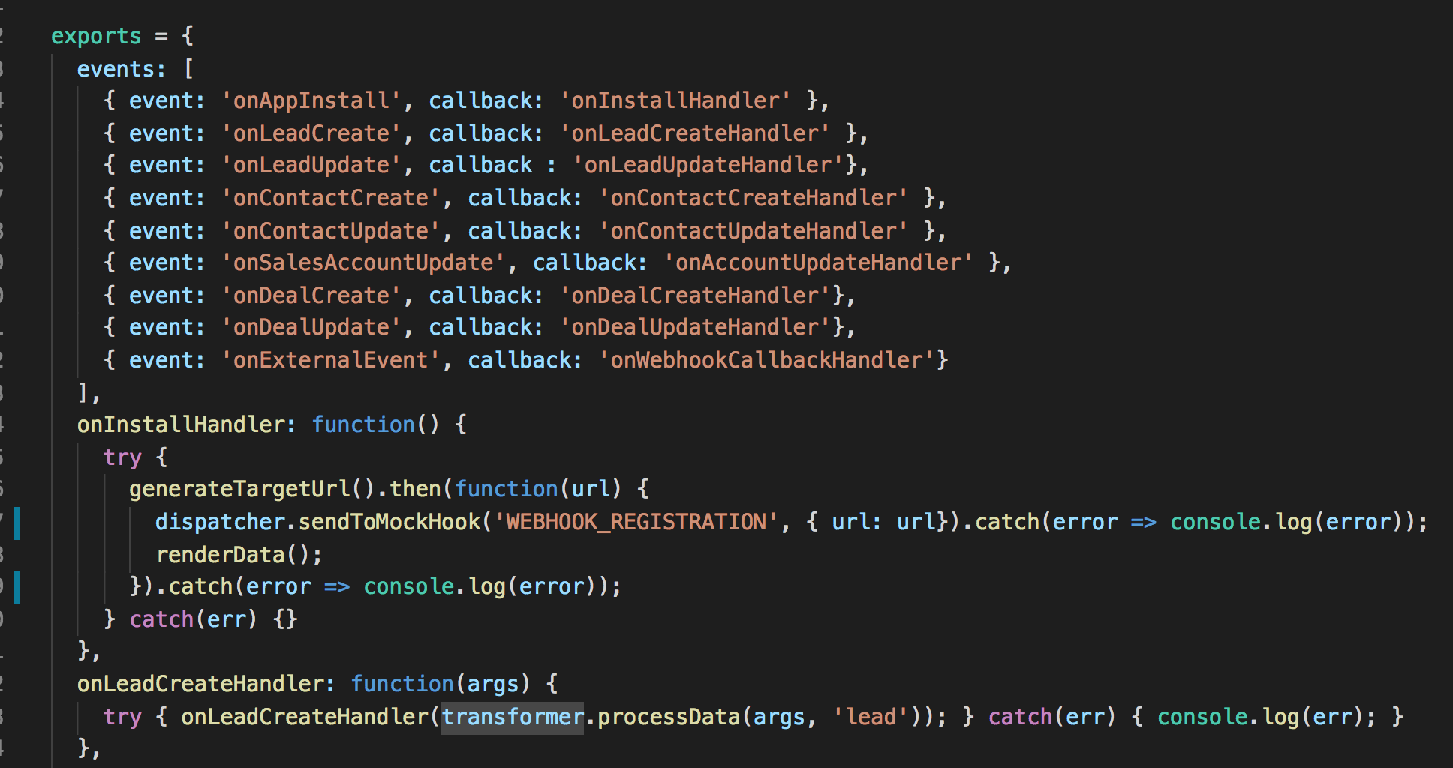

**Events supported:**

* onAppInstall
* onAppUninstall
* onContactCreate
* onContactUpdate
* onDealCreate
* onDealUpdate
* onLeadCreate
* onLeadUpdate
* onSalesAccountCreate
* onSalesAccountUpdate
* onCustomModuleCreate
* onCustomModuleUpdate
* onTaskCreate
* onTaskUpdate
* onTaskDelete
* onAppointmentCreate
* onAppointmentUpdate
* onAppointmentDelete
* onExternalEvent

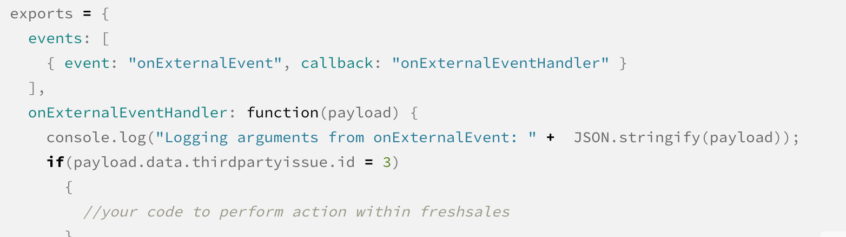

Generating webhook url

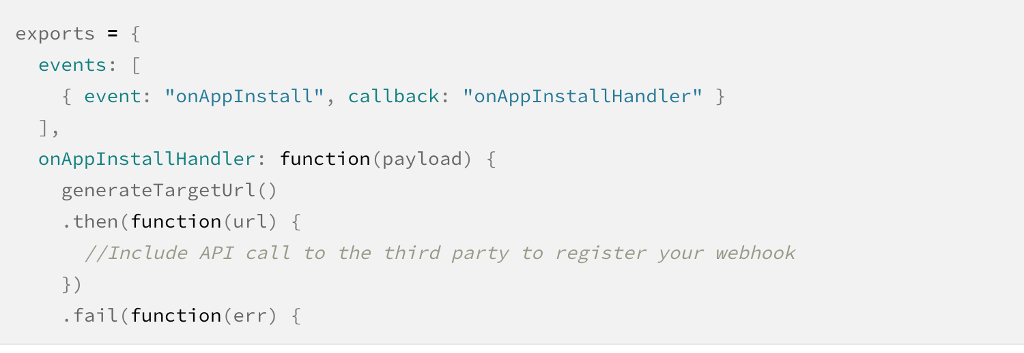

**Server method invocation**

